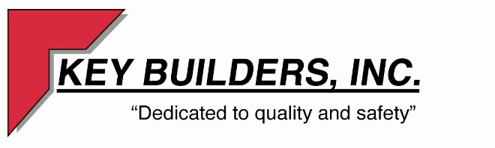

Apache Mall- Nimbus Playhouse
Option 3
Scope of Work

- Provide Architectural Drawings for permitting
- Demolition of walls noted on plan page A-200.03 of the “Nimbus Playhouse option 1”
- Demolition of walls and ACT ceiling in noted space on plan page A-200.03
- New Demising wall to deck- approx. 18’ tall wall as noted on plage page A-200.03
- New demising wall to be fire taped and sanded- No paint
- New sprinkler valve will be required to separate space
- Separate RTU for this space- Design by HVAC
- Extend 4” sanitary line from bathrooms into larger space
- Extend ¾” water line into this space.
- Bag all smoke detectors for demolition as noted on plan page A-200.03
- Temp lighting installed as noted on plan page A-200.03
- Separate electric for two spaces
- Separate sprinkler for two spaces
- Option 3 to include the following:
- Demo of entire noted demising wall on plan pages A-000.03 and A-200.03
- Framing, drywall patching, and taping required where wall is opened up.

